Dev Art 2014 Competition
Travel Release Form

STATE OF: Antioquia COUNTRY OF: Colombia

FINALIST: I, Jorge Ocampo Rendón being duly sworn say I am 32 years of age.

I reside at:
Calle 23 Sur # 27- 43 apto 106 Envigado Antioquia / Colombia 055420
(Street Address) (City) (State/Country) (Zip Code)

I acknowledge and understand that neither Google Inc. nor Marden-Kane, Inc. have arranged for, or carry insurance of any kind for our benefit or that of our heirs, executors or administrators relative to going on said trip; and that I am solely responsible for obtaining and paying for any life, travel, accident, property or other insurance relative to going on said trip.

In consideration for the travel package I receive as a Finalist in the “Google Dev Art 2014 Competition”, and for other good and valuable consideration, the receipt of which is hereby acknowledged, I, for myself, my heirs, executors and administrators, hereby waive, release, discharge and agree to indemnify and hold harmless Google Inc., its affiliates, subsidiaries, divisions, agencies and Marden-Kane, Inc., all of the foregoing entities’ respective officers, directors, employees, shareholders, and agents associated with the “Google Dev Art 2014 Competition” from and against any and all claims, actions and/or liability, for any injuries, loss or damage of any kind whatsoever, including attorney fees, arising from or in connection with my participation in and/or entry into the competition or acceptance and/or use of any prize won (including, without limitation, any prize-related travel or activity or the acceptance and/or use of the Finalist Prize).

I understand that in connection with this Event, Google may disclose to me certain information that is proprietary to Google ("Confidential Information"). I will use the Confidential Information only for the purpose associated with my visit. I will use the same degree of care, but no less than a reasonable degree of care, as I use with respect to my own similar information to protect the Confidential Information and to prevent (a) any use of Confidential Information not authorized in this Agreement, (b) dissemination of Confidential Information to any third party. This Agreement imposes no obligation upon me with respect to Confidential Information that (a) was known to me before receipt from Google, as evidenced by my files and records in existence before the time of disclosure; (b) is or becomes publicly available through no fault of me; (c) is rightfully received by me from a third party without a duty of confidentiality; (d) is disclosed by Google to a third party without a duty of confidentiality on the third party; or (e) is disclosed by me with Google's prior written approval. If Confidential Information is required to be produced by law, court order, or governmental authority, I must immediately notify Google of that obligation.

This Agreement shall remain in effect until such time as all Confidential Information of Google disclosed hereunder becomes publicly known and made generally available through no action or inaction of mine. I, upon Google's written request, will promptly return all Confidential Information received from Google, together with all copies, or certify in writing that all such Confidential Information and copies thereof have been destroyed. Google does not wish to receive any Confidential Information from me, and Google assumes no obligation, either express or implied, for any information disclosed by me. Furthermore, this Agreement imposes no obligation on Google to exchange Confidential Information, to proceed with the business opportunity, or to purchase, sell, license, transfer or otherwise make use of any technology, services or products.
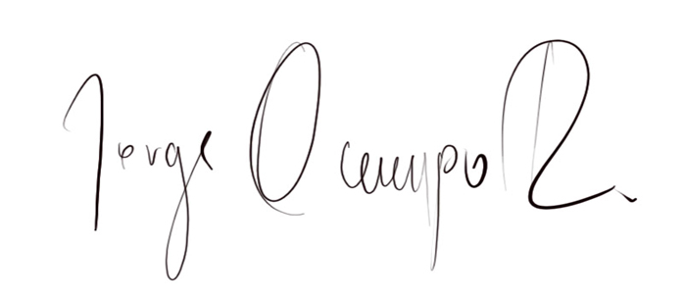

SIGNED:

PARENT/LEGAL GUARDIAN OF MINOR SIGNED:_________________________
(If Regional Finalist is under the age of majority in place of residence)

U.S. ENTRANTS ONLY:

Sworn to before me this ________day of _______________, 20_______.

___________________________________________ (Notary Public Signature) - Seal Must be Affixed -

